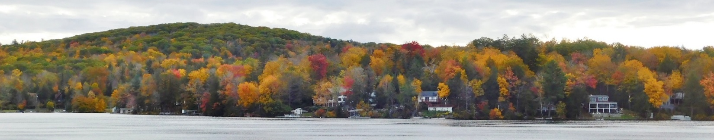
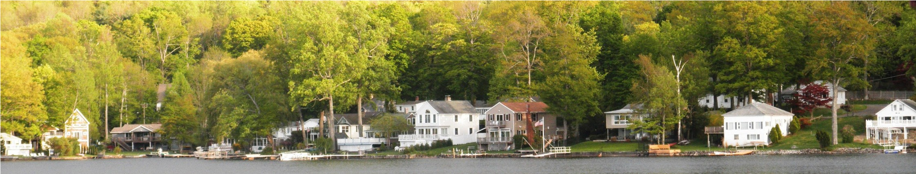


Highland Lake News

From the Highland Lake Watershed Association - A Nonprofit Organization Dedicated to the Preservation and Protection of Highland Lake and Its Watershed

Fall 2026
President’s Message
Highland Lake Neighbors and Friends,
As always, I would first like to thank all of you for being important members of the Highland Lake Watershed Association. Your generosity is greatly appreciated.
When we look around Highland Lake today, it is easy to take for granted the pristine water, vibrant community, and stunning natural beauty that surround us. Today, Highland Lake stands as one of the most sought-after lake communities not only in Connecticut, but throughout the entire region - a fact clearly reflected in our strong property values and record sales prices.
However, the lake we enjoy today is not an accident of nature alone. It is the direct result of decades of vision, dedication, and hard work by past HLWA members, leaders, homeowners, and community partners who recognized early on that protecting our water quality requires constant vigilance and proactive stewardship.
Our current success sits on a foundation built by those who came before us.
- Pioneering Infrastructure: The historic advocacy and relentless effort that led to installing protective municipal sewers in 1994, permanently removing a major threat to our watershed.
- Land Preservation: Securing critical forested parcels through programs like the Legacy Program to protect surrounding green space, preserve our unique lake character, and prevent harmful stormwater runoff from entering the lake.
- Proactive Water Quality Management: Decades of meticulous water nutrient testing, careful monitoring of water levels, and scientific management of aquatic plant life to maintain clarity and ecological balance.
- Targeted Advocacy: Partnering with the Town and State to drive protective drainage projects, including critical improvements around the state boat launch, while consistently raising awareness about runoff and nutrient-rich drainage that threaten our ecosystem.
As we look to the future, the responsibility of this legacy now rests with all new and current owners at the lake. The work of protecting Highland Lake is never truly finished, but with the foundation laid by our past leaders and the continued commitment of our present community, we can ensure that Highland Lake remains a cherished asset and a vibrant home for generations to come. Your help starts on your properties with rain gardens, protective trees and plants, and careful lawn management.
Thank you for your ongoing support, dedication, and love for our lake.
Warm regards,
Candy Perez

What’s Inside  Suggestion Card Feedback and Analysis Report···················· 2  Poker Run Update ··························································· 4  Waterfront Address Identification ········································ 4  Blowing Leaves ······························································ 5  Canadian Wildfires ························································· 5  Protecting Highland Lake: A Renewed Dedication ·················· 6  Lake Water Level ·························································· 6 | Not All Pest Control Companies Are the Same ······················ 7  July Boat Parade ···························································· 7  Stronger Together: A Year of Growth for the  Winchester Land Trust ················································· 8  Mix and Mingle, Annual Meeting, Spring Cleanup ··················9  Membership Application ················································ 10
To see all pages in full color, visit our website - hlwa.org.

Suggestion Card Feedback Summary and Analysis Report (July 11, 2026)
by Candy Perez
This report summarizes the feedback, concerns, and suggestions gathered at the HLWA meeting on July 11, 2026.
Executive Overview and Issue Tallies
The feedback submitted by lake residents covers 14 primary categories. Concerns surrounding Marine Patrol / Water Safety, Wakesurfing / Wake Boats, and Drainage / Water Quality represent the overwhelming majority of community input.
Rank | Issue / Category | Category Count (Tallies) | Primary Focus Areas
 | Marine Patrol and Police Enforcement | 70% | Water safety, Jet Ski proximity, police presence schedules, rule enforcement
 | Wakesurfing and Wave Boats | 46% | Shoreline erosion, banning wake boats, lake width limitations, seawall damage
 | Drainage and Water Quality | 33% | Resha Beach runoff, catch basins, weed control, street drainage, lawn care
 | Road Speed and Traffic Safety | 20% | Speeding on East/West Wakefield, speed bumps, road edge maintenance, signage
 | HLWA Board and Governance | 20% | Property inspections/guidance, youth engagement, neighbor outreach
 | Boat Launch and Invasive Species | 1% | Launch inspections, washing boats prior to entry
 | Docks and Floating Docks | 1% | Unregulated floating docks extending too far into the lake
 | Short-Term Rentals and Dock Rentals | 1% | Airbnb regulations, contact registries, unauthorized dock rentals
 | Taxes and Infrastructure | 1% | Tax freezes/grandfathering for long-term lake owners
 | Other Concerns | 13% | Noise (mufflers), grass clippings in lake, fishermen proximity, Main Street speed

Detailed Focus Area Analysis
- Marine Patrol and Water Safety
Residents expressed deep frustration regarding water safety, lack of visible law enforcement, and noncompliance with boating regulations.
- Police Presence and Scheduling: Strong demand for an increased, predictable police presence - specifically during peak weekend hours (Fridays, Saturdays, and Sundays around 5:00 p.m.).
- Jet Ski and Watercraft Proximity Violations: Frequent complaints regarding Jet Skis and powerboats operating dangerously close to docks, private shorelines, and swimmers. Residents called on Marine Patrol to actively stop and fine violators.
- Licensing and Speed Regulations: Concerns regarding unlicensed drivers (including underage kids) operating Jet Skis, boats with removed mufflers/excessive noise, and general speed enforcement.
- Town and Department Accountability: Suggestions were made to collaborate directly with the Town of Winchester to fund marine officers. Residents noted frustration with hearing annual "excuses" from the police department and requested concrete statistics, facts, and action plans.

- Wakesurfing and Wake Boats
Wakesurfing and high-displacement wake boats emerged as one of the most urgent and unified policy concerns, with the vast majority calling for outright bans or strict limitations
- Lake Narrowness and Suitability: Multiple residents highlighted that Highland Lake is geographically too small and narrow to safely accommodate high-energy wave-generating boats.
- Shoreline Erosion and Property Destruction: Residents reported severe, ongoing shoreline erosion, destruction of seawalls, and structural impact on docks and moored boats caused by massive artificial waves.
- Precedent Cited: Submissions explicitly referenced Lake Waramaug as a regional precedent for successfully restricting or banning wake surfing boats.
- Specific Shoreline Impact Example:
"Resident of 83 years - Erosion from huge waves is taking my shoreline (6 feet over 83 years). Please: outlaw wakeboard type motors from the lake . . ."

- Drainage, Water Quality and Shoreline Management
Runoff management and water clarity were highlighted with specific structural and community-driven remedies.
- Resha Beach Parking Lot Proposal: Detailed suggestion to remove the drain emptying directly into the lake at Resha Beach, construct a lakeside swale leading to a rain garden or downhill drain, and secure the porta-potty to prevent tipping.
- Catch Basin Infrastructure: Requests for catch basins and runoff treatment along East and West Wakefield Boulevard to remove sediments and nutrients before reaching the lake.
- Catch Basin Hood and Hanger Program: A specific proposal submitted by resident to install hoods and hangers on all lake outlet catch basins.
- Community and Maintenance Responsibilities:
- Curbs along the lake side of the road to manage runoff.
- Encouraging property owners to maintain catch basin cleanliness (similar to fire hydrant clearance).
- Enforcing fines for throwing grass clippings and yard waste into the lake.
- Continuing full annual weed control management

- Secondary Themes and Additional Recommendations
Road Safety and Traffic Management (6 Mentions)
- Speeding Controls: Requests for speed limit signs along West Wakefield, yellow center lines on lake roads, and installation of speed bumps designed to accommodate snowplows.
- Main Street: Suggestions to slow down traffic on Main Street and make it a pedestrian-friendly core.
- HLWA Board Governance and Engagement
- Property Consultations: Suggestion for board members to conduct voluntary property "inspections" to offer guidance on runoff prevention, rain gardens, and eco-friendly lawn care.
- Community Recruitment: Programs to actively involve younger generations and encourage members to directly recruit neighboring homeowners.
Lake Usage and Rentals
- Boat Launch Inspections: Mandatory cleaning and inspections at the boat launch to stop invasive species.
- Floating Docks and Dock Rentals: Regulating dock extensions into narrow water passages and cracking down on unauthorized commercial dock rentals.
- Short-Term Rentals and Taxes: Creating a town contact registry for weekly home rentals (Airbnb’s) and exploring tax freezes for long-term resident homeowners to prevent displacement.
HLWA received a donation
from United Way of Salt Lake City, Utah. Unfortunately, the organization was unable to let us know whom the donation was from. If this was from you, please let us know by sending an email to treasurer@hlwa.org
so we can properly thank you!


`

Poker Run Update
by Rick and Carol Josefek
We would like to thank everyone in the Highland Lake community who came out for the HLWA inaugural 50/50 Poker Run. We first envisioned this event at Highland Lake a few years ago. With a lot of planning and support it finally came to fruition.
We are pleased to announce this year’s event was a huge success for a first-time event. We had a total of 87 participants (cards sold).
Since this was such a huge success, we plan on holding the 2nd Annual HLWA 50/50 poker run. Time and dates will be published in the HLWA newsletter, on the HLWA website (hlwa.org), on the “Friends of Highland Lake in Winsted, CT” Facebook page and in the Friends of Main Street weekly newsletter.
From the feedback we received, it seems everyone enjoyed themselves and had a good time. We’ve also heard many people didn’t even know about it, so please spread the word and let everyone you know what a great time you had. Keep an eye out for news next spring!
Thank you for your support!
Waterfront Address Identification
by Karen Jones
During our recent wildlife rescue effort along the first bay shoreline for a wounded Mallard duck, it became evident many waterfront properties lack visible address identification from the water.
In the event of a medical emergency or water rescue, first responders rely on clear visibility. We strongly encourage all residents with lake frontage to post their street numbers clearly on their waterfront side. Highly visible, reflective address signs are widely available online, including on Amazon. Installing one is a simple step that safeguards your property and neighbors when every second counts.
We appreciate your help with this effort.
Resources for Signs -
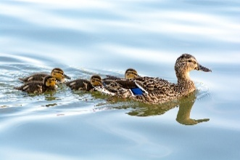
https://a.co/d/0g7zREof
https://a.co/d/07vr8QLY
https://a.co/d/02uwrtrL
https://a.co/d/0btQpGWL

Blowing Leaves
by Denise Pratt
Fall is a beautiful time of year at Highland Lake. Our trees give us a beautiful show of color during foliage season. We are fortunate to have hillside landscapes that are dominated by a mix of hardwood and evergreen trees such as Red and Sugar Maples, Birch, Red Oak and Eastern White Pine, to name of few of the more commonly found. Our New England trees provide benefits, including capturing and storing carbon dioxide, filtering air pollution, filtering and protecting drinking water supplies, controlling storm runoff and soil erosion as well as offering vital habitats for regional wildlife.
Why Trees Shed Leaves
- Water Conservation: Leaves lose a lot of water through tiny pores in a process called transpiration. When winter arrives, the ground freezes, making it hard for roots to pull up liquid water. Dropping leaves stops the tree from drying out.
- Energy Savings: Shorter days and colder weather mean less sunlight. It costs the tree more energy to keep leaves alive than the leaves can make through photosynthesis.
- Storm Protection: Bare branches catch less snow and ice. This prevents heavy branches from snapping during winter storms.
As the leaves fall in our community, we have a responsibility on how to handle fall cleanups. It is bad to blow leaves into a lake. Leaves will naturally enter the lake by dropping from shoreline trees and being blown into it from yards and banks. Intentionally blowing or raking leaves into the water overloads the ecosystem with decaying matter. Overloads of nutrients can cause algae blooms as well as unwanted muck.
Please mention to your landscapers to refrain from blowing any lawn clippings or leaves into the lake. Keep an eye on storm drains in your area to make sure they do not get covered with leaves and other fall cleanup debris.

If you are unable to clear a storm drain in your area, please call the Town of Winchester Public Works to report covered or clogged storm drains. Public Works - 860.379.4070.

Canadian Wildfires - How Lakes Are Affected
by Betty Martin
As all of us experienced the smoky days this past July and the even worse experience back in the summer of 2023, we are seeing that a fire does not need to burn within a lake’s watershed to affect the people and ecosystems around it. Lakes are increasingly exposed to wildfire smoke at much higher intensities and for longer durations than just a few years ago. Canada’s 2023 wildfire season was the most destructive ever recorded there. Extreme weather, record high temperatures and dry conditions caused by climate change intensified that year’s wildfire crisis.
For the Canadian fires this past summer, Connecticut Department of Energy and Environmental Protection (DEEP) issued a statewide fine-particle air-quality alert as smoke from the fires in southern Ontario moved over our state. The immediate concern is human health, but lake communities should also recognize smoke as a short-lived environmental disturbance that may alter sunlight, temperature, nutrient delivery, and biological activity in lakes.
Only relatively recently have researchers begun analyzing the impact of wildfire smoke on lakes using remote sensing and satellite data to quantify the problem. Thick smoke plumes can shade the water surface, changing light transmission and reducing UV radiation that naturally suppresses surface algae. Smoke particles can also deposit nutrients like phosphorus, potentially increasing algal blooms, especially after rain mobilizes these nutrients. Studies conducted in 2024 in the Finger Lakes region of New York showed dissolved phosphorus in a tributary of Cayuga Lake rose to two or three times its pre-smoke concentration.
This does not mean every smoky day will result in an algae bloom, but recent studies do show we need to pay attention both locally and nationally for wildfire impacts. Lastly, it is vital our lake residents pay attention to the air quality index levels issued by DEEP and limit certain outdoor activities during the worst of it, especially for those with respiratory issues.

Protecting Highland Lake: A Renewed Dedication
by Candy Perez
Since 2009, when the Board of Directors - led by President Dick Labich and Treasurer Mike Peacock - introduced the Legacy Program, the Highland Lake Watershed Association (HLWA) has remained steadfast in its core mission: keeping our water clean and protecting the lake’s ecological and property value for present and future generations.
Beyond tracking water clarity and chemistry to monitor aging trends, our primary proven strategy for long-term health has been and is currently land conservation. Preserving forestland within the watershed limits stormwater runoff and controls the influx of phosphorus - the primary nutrient driving harmful weed and algae growth. Securing open space permanently mitigates these environmental threats, safeguarding our community’s character, scenic beauty, and protecting your individual investments in property.
Our Conservation Legacy in Action
Through community generosity and key partnerships, we have already made a lasting impact. The character of Highland Lake and environmental quality of the water has made us one of the most sought-after lakes in Connecticut and beyond.
- Long Pond Ridge (2007): Purchased a historic eight-acre parcel on the west side of the lake using resident donations and a state grant, entrusting it to the Winchester Land Trust (WLT) for permanent protection.
- Stevens Preserve (2014): Partnered with the WLT to acquire five critical acres on East Wakefield Boulevard for open space preservation.
- Laurel Ridge (2025): HLWA led the project and partnered with the WLT to purchase historic and critically important Laurel Ridge parcels with help from DEEP Land Acquisition, Highlands Conservation Program administered by the U.S. Fish and Wildlife Service, John T. and Jane A. Wiederhold Foundation, Highland Lake Watershed Association, Farmington River Coordinating Committee, Northwest Community Bank Foundation, Connecticut Land Conservation Council’s Land & Easement Acquisition Program and Transaction Assistance Program, as well as generous individual donors the Babcock Family, Claire and Bob Dombi, Papermaster Family, Archie Perez and Family, Perga and Houlihan Families, Eleanor and Ken Pratt, Terri and Jarry Rasmussen, Joanne and Matt Smith, Ballentine Family, Carlton Fields, John and Valerie Lochner, Mary Ann Marino, Ken Albino and Maria Miele, Brandolini Family, Nancy and Craig Dennen, John Flaherty and Colleen Burke, Bob and Jackie Mulvey, Bob and Maureen Ney, Annie and Greg Simard, Kevin, Marcia and Brenda Winn, Gail and Stuart Yaffee, Champagne/Carter Family, Kelly Hicks, Susan and Robert Bailey, Laura Nash, Shirley Allshouse, Cathie Perga, Deborah Stanizzi, Sarah Camp, John and Carol Young, Sandy Mangan, Chris and Linda Chinnock, Jill and Mark Ricci, John and Jane Aresta,
Dr. David and Stacey Brady, Ron Guralnick, Edward Rapposelli, Susan Hoffnagle, Terry and Willie Platt, Lisa and Jerry Traub, Dr. and Mrs. John Turnier, Betty Martin, Dave Pines, Florence Giomblanco, Needham Family, Jane Biondi, Linda Groppo, Mary Dillinger, Romeo and Sarah Gervasini, John and Carol Young, Frank Oliveri, Tony and Carol Zacchio, Public Safety Research Institute, Keira and Charles Morse, Brigitte and Scott Rouleau, Renee and Steven Marcus, Steve and Rosie Molinelli, Roger D. Coutant, Rhonda Tobin and Jeff Smith, Linda Jessee, Ken Farrar, K&M Meyer Foundation, Charlene LaVoie, Christopher and Linette Branham, Sara and Jonathon Yolles, Carmen Bazzano, Jr., Dave and Chrissy Morris.
- Donated Parcels and Stewardship: Through many dedicated land donors in the past, we have been able to preserve a small amount of the “picnic lots.” We have dedicated HLWA stewards past and present - Mike Peacock and Willie Platt - who work behind the scenes to monitor and maintain these protected properties.
A Call for Renewed Dedication
Protecting Highland Lake is an ongoing promise for all of us, and our work is far from finished. We invite you to renew your commitment to our lake’s future and your investment. Whether you are reflecting on the legacy of land you currently own or looking to support conservation financially, your contribution plays a vital role in keeping this lake vibrant.
How You Can Help
Consider a Land Donation: Preserve the legacy and scenic beauty of your property, protect community character, and explore potential tax benefits.
For questions or to discuss how you can support the Legacy Program, please contact us at hlwa@hlwa.org or 860.309.3972.
Note: Before making a donation or gift of land, please consult your tax accountant or financial adviser.
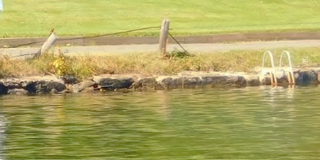
Lake Water Level
by Willie Platt
The year got off to a rough start with the lake not reaching its full level until the middle of May. The Public Works Department had a hard time maintaining that level throughout the summer season because of the drought early in the year and all the rain later, so the level never got very high.
Some lake residents experienced trouble getting their boats off lifts. This fall might be a good time to get your lifts adjusted for the varying lake levels. We should prepare
for any changes Mother Nature might have in store for us
next year.
The Water Level Committee will start having meetings soon to create the next five-year drawdown plan which should be ready to start its trek through the permitting process next summer.
Not All Pest Control Companies Are the Same
by Candy Perez
Highland Lake is blessed with our own Bald Eagles, Ospreys, Owls, Red Shoulder Hawks, Foxes and other wildlife, as well as the many pets we all own. We hope to protect them.
Choosing the right pest control methods for managing mice is essential, particularly when it comes to avoiding second-generation anticoagulant rodenticides (SGARs) secondary poisoning.
SGARs are found in bait boxes and are exceptionally potent compounds designed to kill target pests, but the toxins linger and accumulate in the tissues of poisoned rodents. Because mice die slowly after consuming the bait, they leave the bait box and become easy, highly toxic targets for our beautiful raptors. Opting for companies that reject these harsh chemicals prevents the spread of poison through our local ecosystems.
To protect local ecosystems, homeowners must proactively ask pest control providers detailed questions about the exact products they use, pushing for nontoxic exclusion methods, snap traps, or alternative management strategies. It is critically important to safeguard vulnerable wildlife - such as eagles, hawks, and foxes - along with family pets - from secondary poisoning, which occurs when these animals hunt or scavenge rodents that have ingested lethal chemicals. When predators consume contaminated prey, the accumulated toxins frequently cause fatal internal bleeding or weaken them to the point of disease and injury. By demanding transparency from extermination services and refusing second-generation poisons, we can effectively manage household pests while keeping our lake, skies, fields, and homes safe for the natural predators that keep rodent populations in check.
For more information, please see A Place Called Hope. https://www.aplacecalledhoperaptors.com

Best Land Decorations
Jerry, Lisa, Eric, Krista, Matt Traub and son-in-law Ray
July Boat Parade
The 2026 Boat Parade was themed America 250. Many lake families participated in one of our largest parades. We appreciate everyone that made this fun for all!
Best Dressed
Chris Chinook and Friends - "Crossing the Delaware"
Best Vibes and Energy
Katelyn Bailey and Coury DeLancy and Friends
Best Theme
Maryann Marino and Family - "Boston Tea Party"
Stronger Together: A Year of Growth for the Winchester Land Trust
by Mary Ann Marino
On June 6, hikers of all ages gathered at the end of Pratt Street in Winsted to celebrate Connecticut Trails Day and the official opening of the hiking trails at Laurel Ridge. The preserve covers more than 507 acres of forest on the east side of Highland Lake. It was a milestone year in the making, and it was possible only because two local nonprofits, the Winchester Land Trust (WLT) and the Highland Lake Watershed Association (HLWA), worked together to make this dream a reality.
It was also the high point of a remarkable year for the Winchester Land Trust. Over the past twelve months, in addition to opening Laurel Ridge to the public, WLT added two new preserves, expanded its educational programs, and increased their volunteer corps that lets a small organization accomplish a lot.
Laurel Ridge
For Highland Lake, the benefits of Laurel Ridge are concrete. Forested land keeps phosphorus locked in the soil rather than washing into the lake, where it feeds weeds, harmful bacteria and algae. Northeast Aquatic Research's 2020 assessment found Highland Lake in relatively good condition but warned that "in the absence of efforts to reduce nutrient loads, the lake condition will inevitably worsen over time." Laurel Ridge adds a permanent layer of defense. It also protects habitat for two rare, state-listed plant species, including the New England sedge, and forms part of a wildlife corridor linking the Stevens and Cannavo Preserves.
This wouldn’t have happened without the time and attention of so many members of the community including HLWA members, Shelley Harms (grant writer), and Attorney Jeff Smith and his firm Carlton Fields who provided pro bono legal expertise alongside his colleague, Jeremy Mudd.
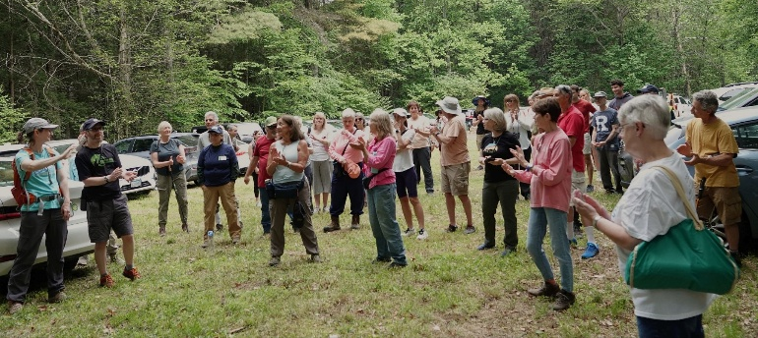
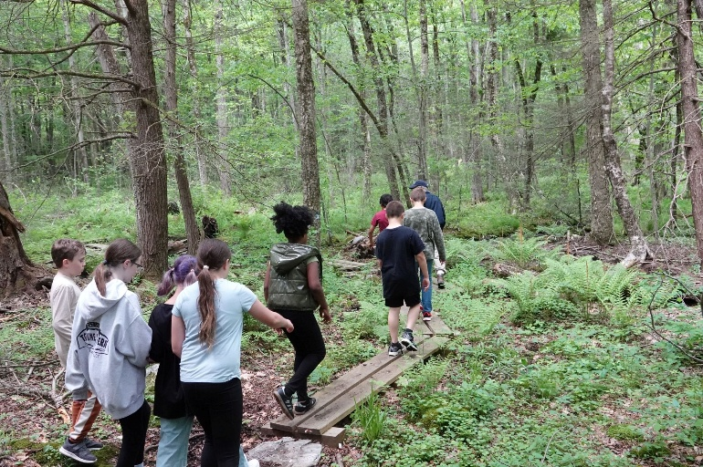
On Connecticut Trails Day on June 6, 2026, hikers explored the quarter-mile loop around Carey Trotter Park, a racetrack that was active in the 1920s and whose outline is still visible today, as well as the more demanding Ridge and Long Pond Trails, which lead to a scenic overlook. More than 90 people took part. It was a great day to enjoy the hard work that volunteers put in spending long hours clearing and marking the new trails during the months leading up to the event. Trail maps are available on the WLT website,
winchesterlandtrust.org
Two New Preserves
In March, WLT purchased Treiber Field, 15 acres of field, forest, and wetland near the Green in Winchester Center. In early May, WLT closed on the 93-acre Rebillard Forest in the northeast corner of Winchester. The property runs along a half-mile stretch of the Still River, where it will serve as a riparian buffer protecting water that flows on to the Farmington River. WLT is now working to acquire the adjacent 37-acre Rebillard Farm, whose upland fields could be restored as grassland habitat, with closing expected later this year. Plans for the combined property include a low-impact trail system, informational kiosks, and a new field trip destination for local students.
A Lean Board and a Growing Volunteer Corps
WLT's eight-member board includes Jennifer Perga (President), Doug Pfenninger (Vice President), Louise
Van Alstyne (Secretary), Joey Pierce (Treasurer), Caroline Christensen, Barbara Douglas, Jay Martin, and Addie Mehl. Perga calls it "pretty lean and mean," but the board is backed by a network of 50 to 60 volunteers.
"We are so lucky that as we have grown in land, our volunteer base has grown," Perga said. "Because the volunteer base has grown, we can be more effective. More hands on deck."
Stewardship has become more organized. Trail walkers report problems, a trail crew with tools heads out and makes repairs, and land stewards walk the boundaries of each preserve regularly, recording their observations in a mobile app that uploads their reports to a permanent digital recording system. A board member accompanies each new steward on their first visits.
Bringing Kids Outdoors
On May 28 and June 3, Winchester’s fourth and fifth graders from Pearson School took part in WLT's annual field trip, a guided two-mile hike through the Houlihan Woods and Michael Giordano Tribute Area trails. Led by board member Caroline Christensen, students learned about local ecosystems, bird identification, geology, wetlands, native plants, and forest ecology. A grant from FirstLight Energy and community donors made it possible. For many students, it was their first experience in these natural environments.
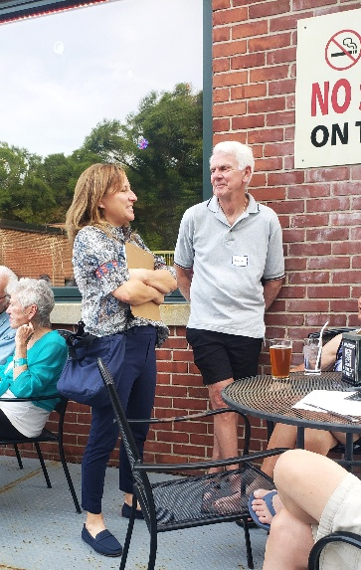
A Busy Year of Programs
WLT's program calendar has grown noticeably over the past year. Recent programs have explored the comeback of the American chestnut at Hurlbut Field, a presentation by Ginny Apple called "Things That Go Bump in the Night," a walk led by Hamish Lutris and Barb Douglas to view "The Magic of Fireflies."
Mix and Mingle
Protecting Highland Lake’s Water Quality
WLT also works with the Farmington River Watershed Association by recruiting volunteers for its rain gardens, including those at the Highland Lake boat launch, the filtration plant, and Resha Beach. Laura Hart of the Farmington River Watershed Association tested the rain gardens. She stated “the total phosphorus, which is really high in the bioswales and below detection level in the lake areas near them, shows they are helping keep out nutrients and bacteria.”
Part of a Larger Network
WLT is accredited by the Land Trust Alliance and is a member of the Connecticut Land Conservation Council, which hosts a statewide conference at Wesleyan University each March, offers board training, and awards acquisition grants. WLT also participates in the Greenprint initiative led by the Housatonic Valley Association and in an annual gathering of small land trusts.
Annual Meeting
Winter and the Year Ahead
Winter is monitoring season. "The leaves are off. You can see the pins," Perga said, referring to boundary markers. It is also when WLT trains stewards and plans its programs.
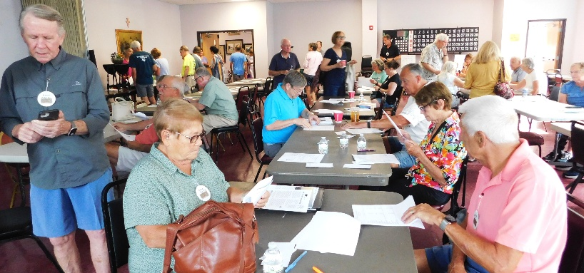
On November 7, at 4:00 p.m., WLT will host an Indigenous speaker, Darlene Kascak, at the American Museum of Tort Law. Next year will bring the Pearson School field trips in late May or early June, the Connecticut Trails Day hike on the first Saturday in June, a spring speaker, and more volunteer-led hikes to introduce residents to WLT's preserves.
Get Involved
WLT is always looking for property stewards and volunteers for trail maintenance and cleanup days. To volunteer, join a hike, or support the Rebillard Farm effort, visit winchesterlandtrust.org, email winchesterlandtrust@yahoo.com, call 860.379.9622,
or follow WLT on Facebook. Donations may be mailed to
P.O. Box 10, Winchester Center, CT 06094.
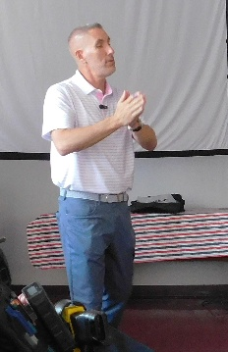
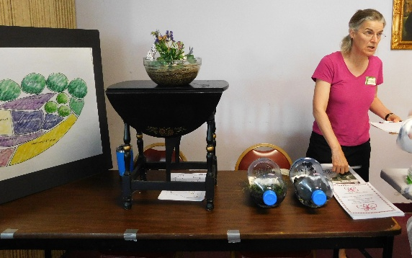
Email: hlwa@hlwa.org
Website: www.hlwa.org
Facebook: Highland Lake Watershed Association
Instagram: hlwainsta
Spring Cleanup

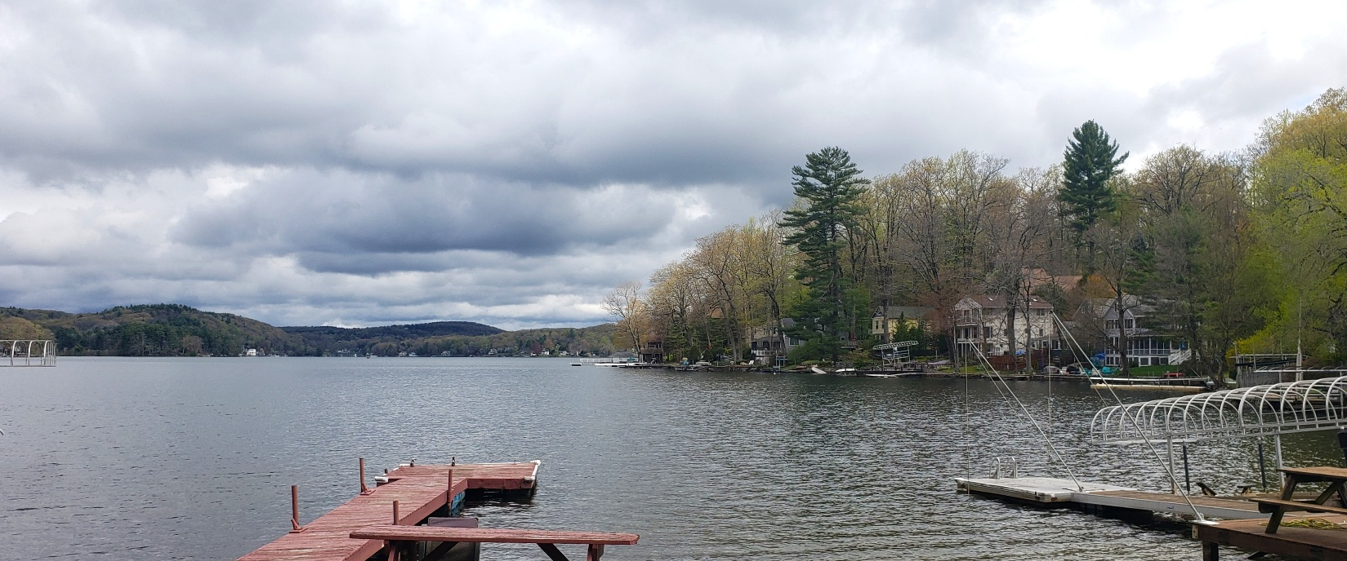
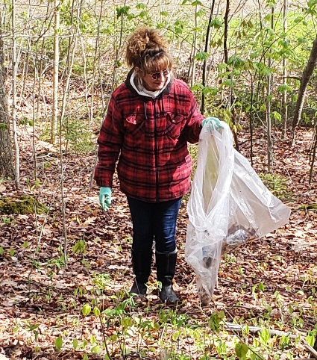
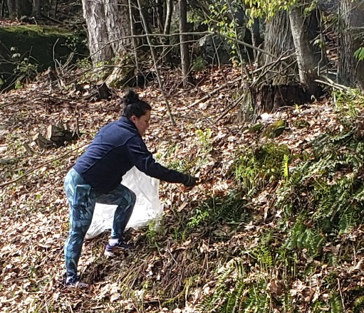
Annual Membership Application
The Highland Lake Watershed Association is a nonprofit 501(c)(3) organization dedicated to the preservation and protection of Highland Lake and its watershed. Your membership (and additional donation) supports the important work of protecting our beautiful lake.
Annual Membership Dues: $50 January 1 – December 31, 2027
Additional Donations:
☐ $25 ☐ $100 ☐ $150 ☐ $200 $ ________________ Surprise us!
$ ________________ Total enclosed
☐​ My employer will match my gift
(Dues and donations to HLWA qualify for IRS consideration as a contribution to a charitable organization and may be tax deductible)
Please make checks payable to: Highland Lake Watershed Association (HLWA) or

Venmo us: @HighlandLakeWatershedAssociation
Mail application to: HLWA, P.O. Box 1022, Winsted, CT 06098-1022

Membership Information

Name(s): ______________________________________________________________________

Lake Address: __________________________________________________________________
​​☐​Mailing address has changed
Mailing Address:_____________________________________________________

___________________________________________________________________
Do you want the summer newsletter mailed to your lake address? ​☐​Yes ​☐​No
Preferred Phone: (____)_______________________________________________
Email: _____________________________________________________________

Volunteers are the backbone of HLWA. We need you!
Yes, I want to volunteer. ☐​ Please have someone contact me (check all that apply)
☐​ Become an HLWA Director ☐​ Welcome new residents ☐​ Cleanup campaigns
☐​ Steward HLWA-owned land ☐​ Write a newsletter article ☐​ Plan social activities
(Application is also available on our website www.hlwa.org)

